


Contents
Group and System Details 3
Front End System Enhancements 4
DFD’s For The Website 5
Context Level Diagram 5
Level 0 DFD 6
Website User Stories 9
Website Design Documents 13
Site Map Diagram 13
Page Description Table (PDT) 14
Website Security 16
Website Usability Strategy 18
1. Nielsen’s Usability Heuristics 18
2. Shneiderman’s Eight Golden Rules 20
3. Tognazzini’s First Principles of Interaction Design 21
References 23

Group and System Details

Group No | Group/System Name
14 | MultiGroup Systems

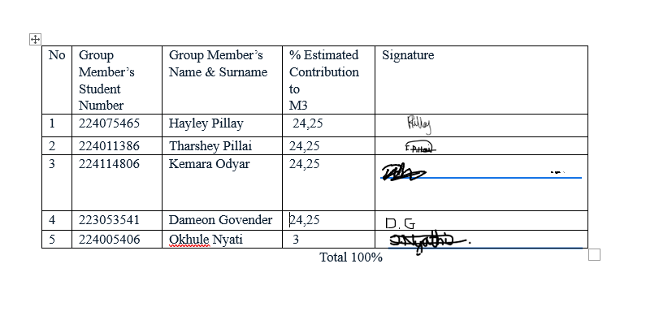

Front End System Enhancements

While refining our Major Project 2 system we heavily considered the feedback received from both our mentor and panellists. Through this brainstorming process we established 4 major areas for improvement of our M2 system. These improvements are as follows:
Aspect of Improvement for the Front-End System (FES) | What was done to enhance this aspect of the FES | Level of Success (High, moderate, low)
Interactivity of system | Across the project we added pop-ups and more clickable options to make the system seem more intuitive to the user | High
Logical issues when adding a new product | Our previous system allowed manual entry of new products into the system. This while applicable as Multi Group Incorporated has a wide range of offerings, could ultimately to incorrect data being entered into the database. We corrected this by added a combo box with autofill capabilities that allows both manual entry as well as has a pre-populated list of items from the database that a user can select from. | High
Error Handling | Our initial M2 system did not have error checking for every method implemented. We went through every page for M2 and corrected this | High
Supplier Order page added | Previously our system had no way for employees to place orders for new stock, consequently a new page has been added to address this. | High

DFD’s For The Website

Context Level Diagram

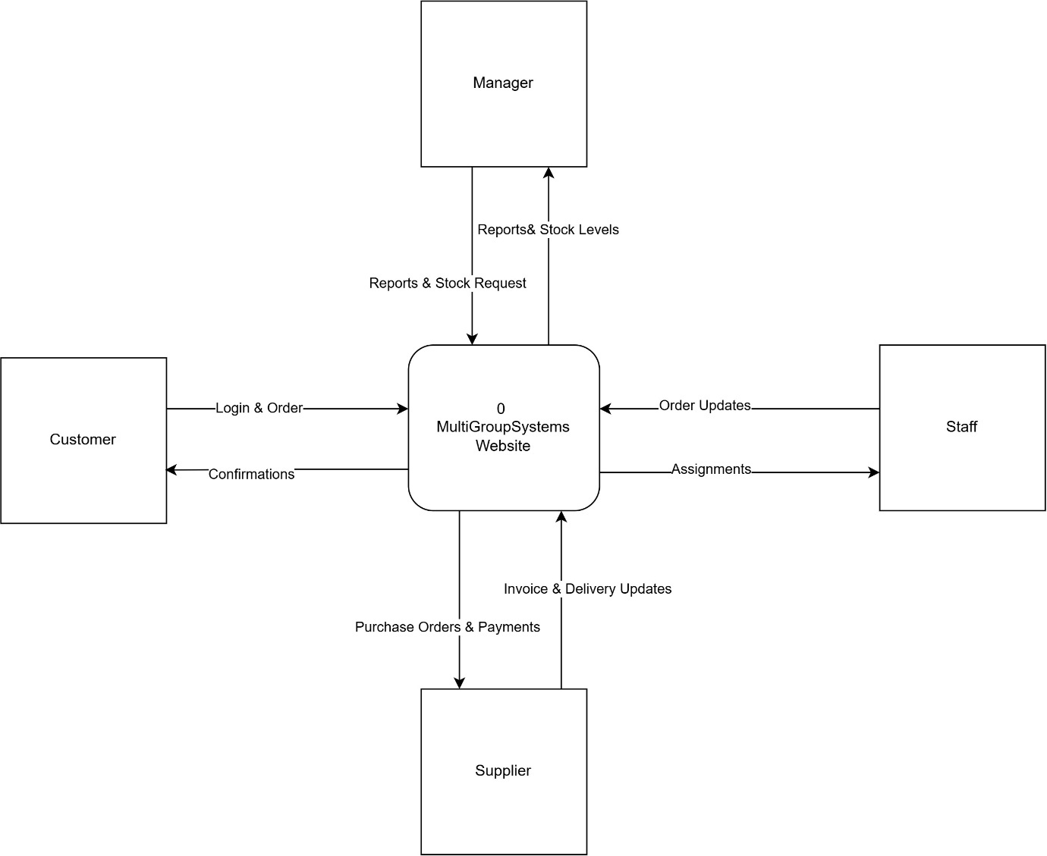
The context-level diagram provides a high-level view of the MultiGroup Systems website processes, which are represented as a single Process 0. The context level diagram illustrates the relationships between the website and four external entities: Customer, Manager, Staff, and Supplier.
First, the Customer is the external entity most closely related to the MultiGroup Systems website since it is the user of its public-facing area. The customer is required to log in (or register to have the possibility to log in) to the website to make an order; thus, a customer’s every activity is connected to the Process 0. In turn, the system provides Customer with the order confirmation and delivery tracking information; therefore, the two data flows represent the confirmation of order and delivery.
Second, the Manager is the external entity that is next in line in terms of significance to the MultiGroup Systems website. The Manager initiates a request for report and stock information. The system responds with the requested reports and stock data; thus, the data flow between the Manager and the Process 0 represents the report and stock information exchange.
Third, the Staff is an external entity that is a part of the organization; therefore, the Staff interacts with the web-based application to perform its day-to-day operations. The Staff enters the order processing and stock update data; in turn, the system provides the Staff with the customer’s order information. The Staff’s order processing area is accessible only to the authorized persons; thus, another two data flows represent the order processing and the order data.
Finally, Supplier is the external entity that collaborates with the MultiGroup Systems website to ensure that there is always inventory available for purchase. The system’s process 0 sends the purchase order to the Supplier after the inventory has been updated. Simultaneously, the supplier sends the invoices and delivery updates to the Process 0, which keeps the information about the delivery status up to date. The data flows represent the purchasing information and delivery updates.
In summary, four external entities are involved in the processes of the MultiGroup Systems website. The Customer interacts with the Process 0 to make the order, which is confirmed by the system’s response. The Manager requests the report and stock data from the Process 0. The Staff accesses the Process 0 to update the inventory and process the customer’s order, which is then sent back to the Staff. Lastly, the Supplier provides the MultiGroup Systems website with inventory information upon the system’s request, and the invoices and delivery updates are sent to the Process 0 as well.

Level 0 DFD

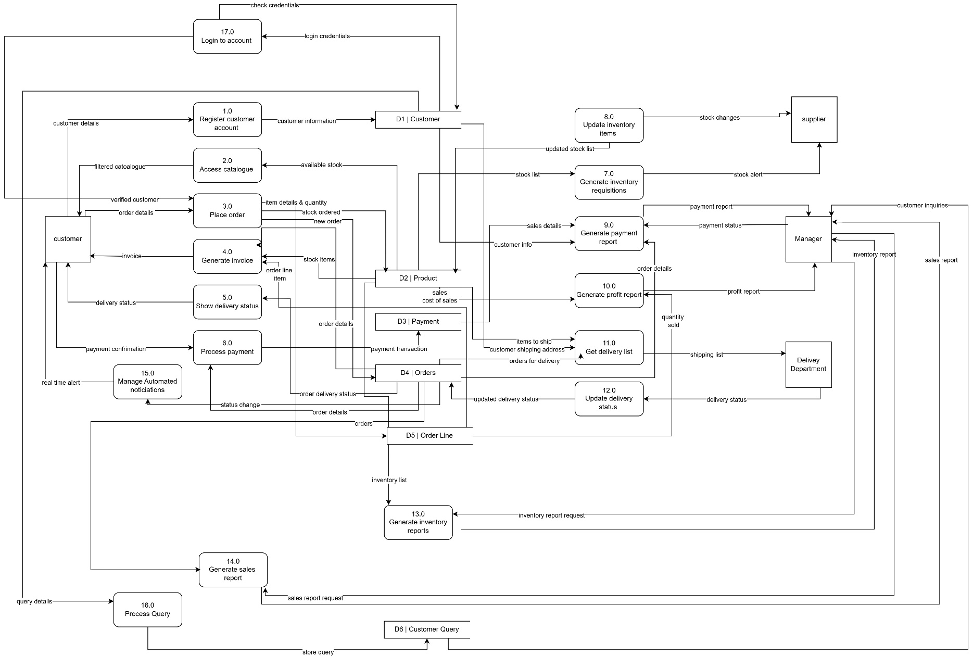

The Level 0 data flow diagram models the flow of data within the system. It identifies the external entities, system processes, and data stores, as well as how information is exchanged.

For new customers, activities begin with process 1.0, Register customer account, in which customer details are recorded and stored in the D1 Customer data store.
Note that customers must login to their account before they can place an order. Therefore, for returning customer begin with process 17.0 Login to account, which validates the customers details with the ones stored in the D1| customer data store
One logged in, the customer may interact with process 2.0 Access catalogue, where they can view all the products. This process retrieves the product information from the D2| Product data store. If the customer wishes to buy an item, they then interact with process 3.0 Place order. This process handles the transaction and stores the order details in the D4|Order data store and D5|Order line data store. The customer then gets an invoice generated by process 4.0 Generate invoice, while process 6.0 Process payment updates the D3|Payment data store.
If a customer has a query, they can submit a message/request through process 16.0 Process query, their query details are stored in the D6|Customer query data store, where a manager can review it.
Process 7.0 Generate inventory requisitions alerts the supplier when stock levels are too low. Following the supplier replenishing stock, process 8.0 Update inventory items, is then used to ensure changes are reflected and stored in the data store D2|Product
The website can also product statistical reporting using processes 9.0 Generate Payment report, 10.0 Generate Profit report, 13.0 Generate Inventory Report, and 14.0 Generate Sales report. These reports are accessed by the manager for business insights. Delivery is managed by process 11.0 Get delivery list and process 12.0 Update delivery status, which is stored in the D4|Order data store. Process 5.0 Show delivery status provides delivery status updates by interacting with D4|Order ensuring customers get up to date progress on their delivery.
Finally process 15.0 Manage automated notifications, ensure that real-time updates are sent to customers regarding order status and payment. This structure ensures data consistency and supports real-time decision making within the organisation

Website User Stories

Title:  Login to account | Priority:  High | Estimated Time:  1 day
As a customer

I Want to Login using my credentials

So that I can access my profile and place orders
Acceptance Criteria:
Given that the customer has a register account

When the customer enters their username and password

Then the system will give them access to their profile and allow them to place orders

Title:  Register an account | Priority:  High | Estimated Time:  1 day
As a customer

I want to register an account

So that I can place orders
Acceptance criteria:
Given that the customer doesn't have an already registered account

When the customer enters their details

Then the systems register them and stores their details

Title:  View catalogue | Priority:  High | Estimated Time:  1 day
As a customer

I want to view products

So that I can check product descriptions and prices before buying
Acceptance criteria:
Given that the catalogue page is loaded

When the customer clicks on Shop

Then the system loads all products, descriptions and prices
Title:  Place an order | Priority:  High | Estimated Time:  1 day
As a customer

I want to add items to my cart

So that I can purchase those products
Acceptance criteria:
Given that the customer is logged into an account and has items in the cart

When they checkout their cart

Then the system processes the order

Title:  Track delivery | Priority:  High | Estimated Time:  1 day
As a customer

I want to track my order delivery status

So that I can track its progress and know when to expect it
Acceptance criteria:
Given that the customer has an order

When customer enters their OrderID in the tracking page

Then the system shows the status of their delivery

Title:  Submit a query | Priority:  Medium | Estimated Time:  1 day
As a customer

I want to submit a query or message or request

So that I can get help with any issue regarding my orders
Acceptance criteria:
Given that the customer is on the contact page

When they fill out the query form and submit

Then the system stores the query for staff to reply to

Title:  Login to profile | Priority:  High | Estimated Time:  1 day
As an admin

I want to login into my profile securely

So that I can access administrative functions
Acceptance criteria:
Given that the admin has valid login credentials

When the admin enters their username and password

Then they would be granted access to the website functions

Title:  Update order status | Priority:  High | Estimated Time:  1 day
As an admin

I want to update the order status

So that the current the current stage of the order is accurately reflected
Acceptance criteria:
Given that an order is being processed

When the admin changes the order status

Then the website should save and display the updated order status

Title:  Tracking an order | Priority:  High | Estimated Time:  2 days
As an admin

I want to track customer orders in real-time

So that I may monitor the progress of each order ensuring timely fulfilment and improving customer satisfaction
Acceptance criteria:
Given that an order exists

When the admin searches for the order

Then the website should display the order’s current status
Title:  View performance reports | Priority:  High | Estimated Time:  3 days
As a manager

I want to view performance reports

So that I can analyse order trends and operational performance
Acceptance criteria:
Given that the order data exists on the website

When the manager selects the type of report

Then the website produces a report based on that selected data

Title:  View pending orders | Priority:  High | Estimated Time:  2 days
As an Admin/Manager

I want to view pending or delayed orders

So that I can identify and resolve operational bottlenecks
Acceptance criteria
Given that some orders are not yet complete

When the manager requests the pending or delayed order list

Then the website will display all pending and delayed orders

Website Design Documents

Site Map Diagram

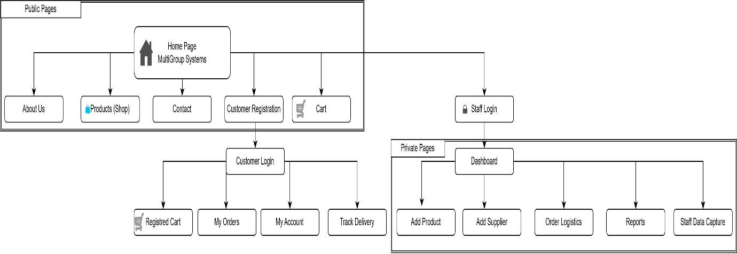

Page Description Table (PDT)
Page Name | Main Functionality | Sub-Functions
Home Page (/Default) | Home Page | View Welcome Banner
Home Page (/Default) | Home Page | View Feature Highlights
Home Page (/Default) | Home Page | Navigate to Shop
Home Page (/Default) | Home Page | Navigate to Contact
Shop(/Products) | Products Page | Search Products
Shop(/Products) | Products Page | Filter by Category
Shop(/Products) | Products Page | View Product Details
Shop(/Products) | Products Page | Add Products to cart
Cart(/Cart) | Shopping Cart | View Cart Items
Cart(/Cart) | Shopping Cart | Update Item Quantity
Cart(/Cart) | Shopping Cart | Remove Item
Cart(/Cart) | Shopping Cart | Proceed to Checkout
Checkout(/Checkout) | Checkout | Enter Delivery Details
Checkout(/Checkout) | Checkout | Select Payment Method
Checkout(/Checkout) | Checkout | Place Order
Checkout(/Checkout) | Checkout | View Order Confirmation & Invoice
Track Delivery(/TrackDelivery) | Delivery Tracking | Enter Order Number
Track Delivery(/TrackDelivery) | Delivery Tracking | View Order Status
Track Delivery(/TrackDelivery) | Delivery Tracking | View Delivery Location on Map
My Orders(/MyOrders) | Order History | View Past Orders
My Orders(/MyOrders) | Order History | Track an Order
My Orders(/MyOrders) | Order History | View/Download Invoice
My Account(/MyAccount) | Account Management | View Profile Details
My Account(/MyAccount) | Account Management | Update Profile Details
My Account(/MyAccount) | Account Management | Save Changes
About Us(/About) | Company Information | View Vision & Mission
About Us(/About) | Company Information | View Core Details
Contact(/Contact) | Contact Information | View General Enquiries
Contact(/Contact) | Contact Information | View Departmental Emails
Contact(/Contact) | Contact Information | View Regional Offices
Contact(/Contact) | Contact Information | Submit Direct Enquiry
Register(/Account/Register) | Account Registration | Enter Personal & Delivery Details
Register(/Account/Register) | Account Registration | Choose Username & Password
Register(/Account/Register) | Account Registration | Create Account
Customer Login (/Account/CustomerLogin) | Customer Login | Enter Username & Password
Customer Login (/Account/CustomerLogin) | Customer Login | Verify reCAPTCHA
Customer Login (/Account/CustomerLogin) | Customer Login | Log in
Customer Login (/Account/CustomerLogin) | Customer Login | Navigate To Register
Staff Login(/Account/Login) | Staff Login | Enter Username & Password
Staff Login(/Account/Login) | Staff Login | Log in
Admin Dashboard(/Admin/Dashboard) | Admin Overview (Mock-up) | Access Quick Actions
Admin Dashboard(/Admin/Dashboard) | Admin Overview (Mock-up) | View Summary Statistics
Admin Dashboard(/Admin/Dashboard) | Admin Overview (Mock-up) | View Sales Overview
Admin Dashboard(/Admin/Dashboard) | Admin Overview (Mock-up) | View Recent Orders
Add Product(/Admin/AddProduct) | Product Management (Mock-up) | Enter product details
Add Product(/Admin/AddProduct) | Product Management (Mock-up) | Upload product image
Add Product(/Admin/AddProduct) | Product Management (Mock-up) | Set stock quantity
Add Product(/Admin/AddProduct) | Product Management (Mock-up) | Add product
Order Logistics  (/Admin/OrderLogistics) | Order Logistics Management (Mock-up) | Enter delivery information
Order Logistics  (/Admin/OrderLogistics) | Order Logistics Management (Mock-up) | Enter shipping information
Order Logistics  (/Admin/OrderLogistics) | Order Logistics Management (Mock-up) | Update logistics status
Add Supplier  (/Admin/AddSupplier) | Supplier Management (Mock-up) | Enter supplier details
Add Supplier  (/Admin/AddSupplier) | Supplier Management (Mock-up) | Add supplier
Staff Data Capture  (/Admin/StaffDataCapture) | Staff Management (Mock-up) | Enter personal information
Staff Data Capture  (/Admin/StaffDataCapture) | Staff Management (Mock-up) | Enter employment information
Staff Data Capture  (/Admin/StaffDataCapture) | Staff Management (Mock-up) | Enter emergency contact
Staff Data Capture  (/Admin/StaffDataCapture) | Staff Management (Mock-up) | Save staff member
Reports  (/Admin/Reports) | Report Management (Mock-up) | View report summary
Reports  (/Admin/Reports) | Report Management (Mock-up) | View recent reports
Reports  (/Admin/Reports) | Report Management (Mock-up) | Browse by category
Reports  (/Admin/Reports) | Report Management (Mock-up) | Create report
Website Security
Access control can be defined as the mediation of every request to data and resources that are maintained by an organisation by a system which determines whether each request should be granted or denied based on regulations established by a security policy (Samarati and de Vimercati, 2001). By this definition Multigroup systems deals with website security by segmenting the user’s accessing our website into 3 distinct profiles namely the general public who merely view what our system has to offer, registered customers who intend to conduct business with us and Multi Group incorporated authenticated staff The resources that these three profiles would be able to access were selectively narrowed down based on both risk as well as accessibility which are elaborated below.
Public access
As depicted in the site map diagram pages such as About us, Shop, Contact and Login are all freely available for the public to browse through. These both satisfy the M3 requirements of having fully developed public pages as well as give individuals a small glimpse at what Multi Group incorporated is and what it has to offer.
Registered Customers
These registered pages require customers to provide their names, surname, email, phone number, address and asks them to create a username and password for future reference. These forms validate data that has been entered into the textboxes ensuring that no erroneous data would be entered into the system.
Staff Access
Our current staff pages form apart of the “private” pages on our website and every access to this section of the site is authenticated against the staff logins in our database. On login the session is notably assigned an ASP.NET forms authentication ticket rather than a plain session login.
Outside of access control our system has accounted for security in a number of different ways, namely:

- All functions that require an update to our database (Customer registration, decreasing/ increasing of stock after a purchase etc.) is carried out using parametrised SQL Command queries to prevent against SQL injection.
- Before a customer is allowed to register a captcha check is done to ensure that the user is a human which ensures that our website is protected against malware and automated abuse.
Going forward we plan to prioritise security as our website extends functionality. Firstly, we plan to lock access to certain pages on our staff dashboard to specific roles within our business specifically. For instance, our reports page would only be allowed to be accessed by our managers rather than all staff, as crucial business information is stored here. We would also like to move our passwords from being plaintext comparisons against our database to salted hashing. Lastly, if possible, we would like to incorporate HTTPS sitewide to provide an extra layer of protection.

Website Usability Strategy
The usability principles the group has prioritised, explains why each was prioritised in the context of this specific site, and demonstrates how each principle is currently reflected in the implemented public pages (Home, Shop, Cart, Checkout, Track Delivery, My Orders, About, Contact and the login/registration pages). The strategy refers to three sets of established and broadly accepted usability principles, those proposed by Jakob Nielsen, Ben Shneiderman and Bruce Tognazzini. The reasons behind selecting these three sets of principles are that they were explicitly mentioned in the M3 brief as the basis for the website usability strategy.

Nielsen’s Usability Heuristics
Jakob Nielsen’s ten usability heuristics have become the most popular list of principles that can be used to assess the user interface of interactive systems. The ten categories include visibility of system status, error prevention, consistency and standards and recognition rather than recall among others (Nilesen 1994). Nilesen and Molich developed their heuristic evaluation methods based on their own evaluations of several user interface designs and concluded that the approach was effective software design evaluation before actual product releases (Nilesen and Molich 1990). The principles can be applied to both the transactional processes of the Multigroup Inc. shopping cart and checkout process as well as more complex and specialized systems.
Of the ten heuristics the group prioritized visibility of system status, error prevention, consistency and standards, recognition rather than recall and match between system and real world as the most relevant to the transactional website designed.
- Visibility of System Status
Customers are allowed to browse and add to cart before being redirected to the log in page where they can log in if they are returning customers or create a new account for first time buyers. This shows that the system has clear communication with the cart state throughout the pre-login phase and this makes the transition seamless as the customers progress doesn’t lose their progress or feel abrupt. This is demonstrated on the Cart page, where changing the quantity of the items or removing them affects the Subtotal and the Total right away, and by the reminder of the number of items in the Cart in the navbar, which is persistent even when navigating to other pages regardless of the login status. Another example is the Track Delivery page, which also implements a similar heuristic by showcasing the delivery’s progress via a horizontal progress bar (Ordered → Shipped → Out for delivery → Delivered), which is achieved by inputting the Order ID.
- Error Prevention
Login is now a mandatory step before checkout, meaning that issues during this stage prevent customers from purchasing any products as opposed to being an added convenience. This is evident by improved forms such as the Province dropdown on the Register page (“Select”) instead of a text field and Google reCAPTCHA v2 on the Customer Login (“I’m not a robot”) which prevent any erroneous submissions as opposed to the previous iteration, where a customer who was unable to login successfully at the end of the checkout process would have to return to the cart, which they might have abandoned by then.
- Consistency and Standards
The same navigation bar, accent colour, and footer text/images are visible throughout the group of websites captured in the screenshots – Home, Shop, Cart, Track Delivery, About Us, Contact, Customer Login and Register. The sole exception is the absence of the “Remember me” checkbox and reCAPTCHA on the Staff Login page, which is expected as the staff area is a separate application designed to be accessed by a different audience of users.
- Recognition Rather Than Recall
The Shop page, as customers browsing the catalogue do not have to keep track of each item’s attributes on their own between pageviews. While the Products page displays the necessary information about each item (category, price), the addition of the “(details)” allows an additional means of discovering more information (“Quantity” + “Add to cart”) without having to navigate away from the page.
- Match Between System and The Real World
Informational pages such as About Us and Contact, where the purpose of the page is to effectively convey information to the user. In the case of About Us, it has been localized appropriately with familiar language (“Our company has been operating for over 40 years”) and recognizable sections (Vision, Mission, and Core Values) as opposed to using internal jargon. On the Contact page, the information is organized in a manner which mirrors how a customer would attempt to contact the company themselves, grouping the available methods of communication into General Inquiries and Departmental Emails, and listing available offices by location rather by their internal designations.

Shneiderman’s Eight Golden Rules
Ben Shneiderman’s Eight Golden Rules of interface design were developed specifically for interactive systems and complement Nielsen’s heuristics by focusing on the mechanics of interaction such as consistency, informative feedback, error handling and reduction of short-term memory load (Shneiderman 1986). These rules are particularly relevant to a data-driven website such as this one, where the same customer repeats similar actions (browsing, adding to cart, checking order status) many times.
The group prioritised strive for consistency, offer informative feedback, design dialogs to yield closure, reduce short-term memory load, and permit easy reversal of actions heuristics as they govern the mechanics of a repeat-action, transaction-heavy interface.
- Strive for Consistency
In the same manner as per Nielsen’s heuristic, through the unified master page and component styling seen across all public pages, most visibly on every captured screenshot of the live site, including the Customer Login, Register, and Staff Login pages.
- Offer Informative Feedback
Due to the number of actions on the site which involve processes the customer cannot see, such as invoice generation and order confirmation (Brevo email, TextBee SMS). This heuristic is most visible on the Cart page, where every adjustment to quantity immediately updates the Subtotal and Total fields, and the Track Delivery page, whose stepper illustrates the status of the order. Another example is the Contact page, where the operating hours are explicitly stated (Mon – Fri 8:00 AM – 5:00 PM).
- Design Dialogs to Yield Closure
The Checkout page follows the same pattern as the Register page, with an additional step of selecting a payment method (cash, card, or EFT) as the final step before order confirmation. This way, the customer has a clearly defined end of the interaction, which is now made explicit by the login/register step at the beginning of the Checkout process.

- Reduce Short-Term Memory Load
A heuristic that directly informed the design of the Shop and Cart pages. It follows Nielsen’s recognition rather than recall principle, as prices, categories, and quantity adjusters are placed on the same line for the Shop page, and the Cart page’s Total field is always visible, reducing the cognitive load on the customer, who must now also remember what they have in their cart across the login/register step.
- Permit Easy Reversal of Actions
The Cart page is directly visible in its design. Every line item has a quantity adjuster and a Remove button, meaning that the customer can easily amend their selections without having to abandon the cart or the entire order, including the login/register step, before returning to the Shop page.

Tognazzini’s First Principles of Interaction Design
Bruce Tognazzini’s first principles of interaction design extend Nilesen’s and Shneiderman’s work with a stronger focus on state management, anticipation of user needs and reducing the cognitive load involved in multi-step interactions (Tognazzini 2014). This is directly relevant to the groups checkout flow where the system must retain cart contents and payment selections across several steps without losing state.
The group prioritised state, anticipation, and consistency, as these principles most directly tackle the multi-step, stateful nature of the Cart-to-Checkout journey.
- State
The most directly applicable principle on this site: the customer can add items to their cart before logging in, so the system must remember their cart state upon checkout instead of throwing everything away at login/register, which would happen if the customer added items to their cart after logging in. This is directly indicated by the navbar’s “Cart (1)” link staying active across Shop, Cart, About Us and Contact even when the user is logged in/out, in every screenshot.
- Anticipation
In the Checkout flow: the system postpones login to the point when the customer is ready to pay, not before, and the Checkout form itself is anticipated to reduce friction by reusing the information the customer has already supplied during Register (name, contact details, address), and presents the payment method (cash, card, EFT) as the final decision to be made.
- Consistency
To reduce the cognitive load on the user during the Register > Cart > Checkout flow, since they now must learn a new UI “surface” (the Register/Login form) to make a purchase. The same interaction patterns (labelled fields, primary-button placement at bottom-left, use of the same colour for secondary buttons) are reused across Register, Cart and Checkout.
The three frameworks above are not applied in isolation either. Stanford’s Improvement, Analytics, and Innovation Services combines the principles above into 12 industry-standard usability principles for evaluating systems, applications, and interfaces (Stanford University Improvement, Analytics, and Innovation Services, n.d.). Notably some of the composite principles overlap considerably with those discussed: User Control and Freedom can be seen in the quantity adjustment controls and Remove on the Cart page; Recognition vs. Recall relates to the in-context information on the Shop page; Consistency & Predictability can be seen in the unified navbar and design language throughout the public website; finally, Feedback is displayed on the Cart in terms of real-time subtotal/total calculations as well as Track Delivery’s current step indicator. Together, the principles represent a consensus of what is considered good UI/UX practice for this website, as opposed to the group simply choosing their favourite principles from Nielsen, Shneiderman, or Tognazzini.

References

- Stanford University Improvement, Analytics, and Innovation Services, n.d. Usability principles. Available at:https://improvement.stanford.edu/resources/usability-principles [Accessed 22 Aug. 2026].
- Tognazzini, B., 2014. First principles of interaction design (revised & expanded). Available at: https://asktog.com/atc/principles-of-interaction-design/ [Accessed 22 Aug. 2026].
- Nielsen, J. (1994) 10 usability heuristics for user interface design. Nielsen Norman Group. Available at: https://www.nngroup.com/articles/ten-usability-heuristics/ [Accessed: 22 August 2026].
- Samarati, P. and de Vimercati, S.C. (2001) ‘Access control: Policies, models, and mechanisms’, in Focardi, R. and Gorrieri, R. (eds.) Foundations of Security Analysis and Design. Lecture Notes in Computer Science, vol. 2171. Berlin, Heidelberg: Springer, pp. 137–196. doi: 10.1007/3-540-45608-2_3.
- Shneiderman, B. (2016) The eight golden rules of interface design. University of Maryland. Available at: https://www.cs.umd.edu/users/ben/goldenrules.html [Accessed: 22 August 2026].
- Tognazzini, B. (2014) First principles of interaction design (revised & expanded). askTog. Available at: https://asktog.com/atc/principles-of-interaction-design/ [Accessed: 22 August 2026].

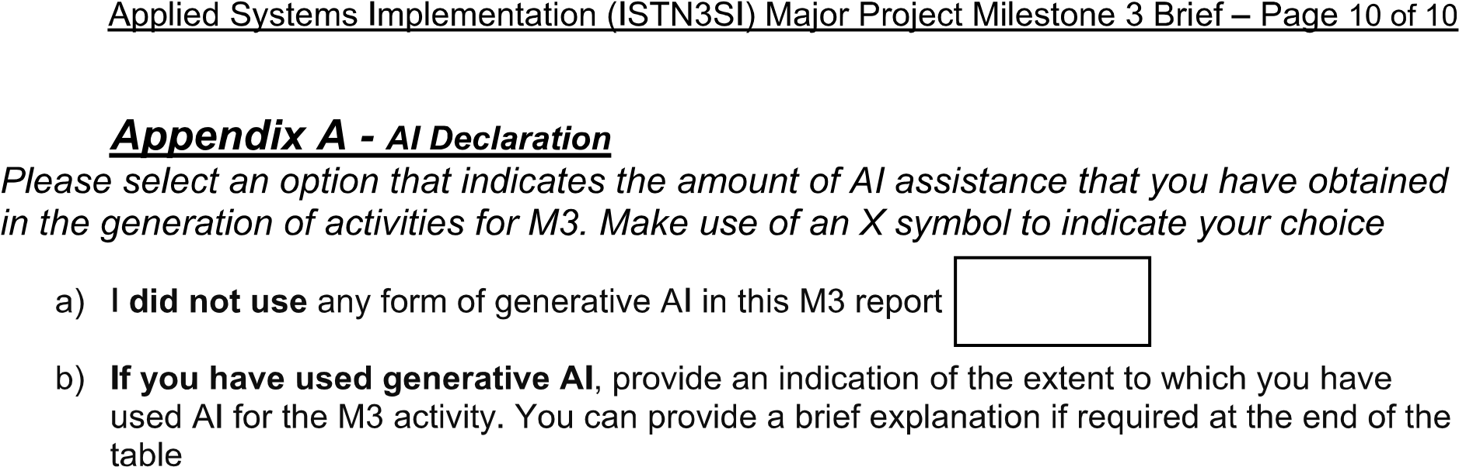
X
X
Gen AI was used for error checking and formatting of references
Hayley Pillay
224075465
24/08/2025

